

**Kindergarten Term 3 Newsletter**

Welcome to Term Three! We have a busy and exciting term ahead.

**English**

Writing remains an important focus and the students will continue to write about their weekend on Mondays, and about various stories read in class.

**Mathematics**

In all aspects of mathematics, emphasis is on conceptual understanding, language and practical activities that enable children to explore numbers and their relationships. We will look closely at two-dimensional shapes, time (clocks), multiplication and division, and area.

**Geography**

Students explore the places they live in and belong to. They develop an understanding of what makes a place special and how this may differ for different people. Students learn about the importance of looking after places. Students explore how the location of places can be represented.

**Science: Living Things**

The Living World strand focuses on living things, their characteristics, needs, behaviours, and the environment in which they live. Students explore how plants and animals satisfy our needs by providing us with the resources for the production of food and fibre. Within this topic, students are introduced to and begin to practise the science skills of observing, questioning, predicting and communicating.

**We will culminate this unit with an excursion to Calmsley Hill Farm on Monday, 28 August (Week 7).**

**PD/H/PE**

**Gymnastic lessons** will take place each week in the hall. All students are required to wear their full sports uniform. Kindergarten students will attend on **Mondays** (no longer on Wednesdays).

**K-2 Gala Afternoon: Week 5 Friday, 18 August**

All children are to come to school dressed in their sports uniform. Children will be in mixed groups which will rotate around varied sporting games. Further information will be provided closer to the date.

**Teddy Bears’ Picnic: Week 10 Wednesday, 20 September**

Kindergarten will be having a Teddy Bears’ Picnic with the kindergarten students starting at HHPS next year. Further information will be provided closer to the date.

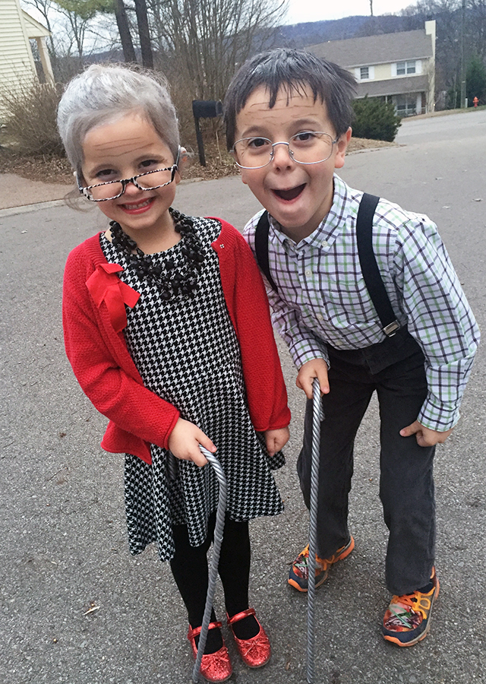

**Kindergarten 100 Days of School: Week 2 Wednesday, 26 July**

Kindergarten will be celebrating 100 days of school this term. There will be a range of fun activities in class, and the students are encouraged to dress up as a 100-year-old!

**Equipment**

As most equipment from Semester One has run out, would you please provide:

* 4 glue sticks(only UHU or Bostik brands)
* 2 tissue boxes

Thank you to all parents for your continued support.

If you have any questions, please do not hesitate to contact your classroom teacher through the school office.

We look forward to a great term!

Regards,

C. Johnston (KJ teacher), E. Xenos (KX teacher) S. Richardson (Assistant Principal K-2)

**NEWS TOPICS TERM 3 2023**

Included in the table below are news topics for Term 3. The topics selected are linked to the literacy, geography and science themes for the term.

**It is very important that students are prepared for their news presentation each week.** Please take the time to discuss the topic with your child and give them a chance to practise. Students may use pictures and photos to assist with their presentation, however, please refrain from the use of technological devices eg. PowerPoint or USB. Thank you.

|  |  |  |
| --- | --- | --- |
| **WEEK** | **TOPIC** | **SUGGESTIONS** |
| **1** | My Holiday | Students talk about two things they enjoyed doing in the holidays and explain why they enjoyed them. |
| **2** | Living Things: Feathers, fur, scales and fins | Feathers, fur, scales and fins: Choose an animal from one of these categories and describe its appearance, diet and habitat. |
| **3** | My Special Place | Students are to talk about a place that is special to them. This could be a holiday house, their cubby house or a place in their home. Why is this place special? How do you feel being there? Draw and label it. |
| **4** | Free Choice | This can be a book, toy, special photo, etc. Why did you choose to share this with the class? Why is it special? Who gave it to you? |
| **5** | My Healthy Meal | Students bring a photo or draw a plate of their favourite healthy meal. Discuss what makes it healthy and why it is important to eat healthy. |
| **6** | Pocket surprise | Students give clues about an object they have in their pocket. |
| **7** | My Favourite Farm Animal | Students talk about their favourite farm animal. Describe its special characteristics, food it eats, name of its ‘home’.  What food/products come from this animal? |
| **8** | Design Your Own Farm | Students create their own farm (diorama or bird’s eye view map drawing) and describe why they put things in particular places e.g. consider what living things need to survive. |
| **9** | My Favourite Plant | Name your favourite plant. What does it look like? When does it grow? Does it flower? What can it be used for? Eg Is it edible? Does it give shade? |
| **10** | Free Choice | This can be a book, toy, special photo, etc. Why did you choose to share this with the class? Why is it special? Who gave it to you? |