**HUNTERS HILL PUBLIC SCHOOL**

**COMMUNICATION PLAN**

**Hunters Hill Public School Communication Plan**

**Introduction**

Hunters Hill Public School (HHPS) is committed to communicating effectively and regularly with our parents, carers and the community. As a school community, there is a significant amount of information to be shared. The distribution of current, clear and timely information is critical for our school and the community.

We will endeavour to keep our school community engaged and informed at all times. This plan seeks to clarify the schools’ communication processes, and sets out the framework we will use to ensure we consistently communicate the right message:

* to the right audience;
* at the right time; and
* using the most suitable communication channel.

This plan is aligned with the [NSW Department of Education’s Code of Conduct](https://policies.education.nsw.gov.au/policy-library/policies/pd-2004-0020) and [Complaints Handling Policy](https://education.nsw.gov.au/policy-library/policies/complaints-handling-policy).

**Objective of our Communication Plan**

Our objective is to build an engaged school community through ongoing, effective and timely distribution and management of:

* outbound information from school to parents and carers; and
* inbound information from parents and carers to the school.

**Our Guiding Principles for Communication**

We will follow our communication guiding principles which include:

* Simplify our approach
* Ensure clarity and timeliness of messaging
* Reduce paper resources where possible
* Understand the information needs of our community
* Avoid duplication where possible
* Remove redundant information and ensure all information is current
* Ensure appropriate privacy practices are followed

**HHPS – Communicating with Parents and Carers**

HHPS uses different ways to communicate information to parents and carers. Communication will be managed via one of the core channels listed below.

|  |  |  |
| --- | --- | --- |
| **Information** | **Channel** | **Description** |
| Urgent matters & emergencies | Telephone with solid fill  Phone calls | Phone-calls will be made to communicate urgent matters eg when a student is unwell at school.  The main school office number is (02) 9816 4404. We recommend you save the phone number to your contacts in your phone. |
| Updates, news, events, recognitions, ‘know & do’, fee notices | Newspaper with solid fill  School newsletter | School newsletters will be issued each fortnight on Thursdays of even weeks. The newsletters will be distributed via email and will also be uploaded and saved to the website for future reference (<https://huntershil-p.schools.nsw.gov.au/communication/newsletters.html>). Earlier editions of the newsletter can also be accessed via the website. |
| Email with solid fill  Email | Key messages will be communicated via email. The main school email address is [huntershil-p.school@det.nsw.edu.au](mailto:huntershil-p.school@det.nsw.edu.au) and the inbox is managed by the school office. This email address should be added to contacts to avoid emails going to junk.  School fees and reminders will be sent via email from a third party called Schoolbytes. Payments can be made using a debit/credit card by clicking the link provided specific to your child/children in the email body. |
| Internet Banking with solid fill  Sentral | Key messages (communicated by email) will also be distributed via Sentral. In addition Sentral is used to provide immediate community alerts, alerts to parents if their child is absent, and a link to the school newsletter. It also enables parents to provide a quick explanation of student absence.  Please see Appendix C for information on how to join or follow this link <https://www.sentral.com.au/getting-started> . You will need your school generated access keys that will have been provided. |
| About our School | Internet with solid fill  HHPS Website | The school website <https://huntershil-p.schools.nsw.gov.au/> is our primary communication channel for reference information about our school**.** It is a comprehensive resource which is growing and contains up-to-date information. It has been designed to be a self-service portal for our parents and carers. We recommend searching the website in the first instance for information required. Use the search function.  Please see Appendix A for an outline of website content. |
| Student Specific Information | **Newspaper with solid fill**  Student  Progress Reports | Student Progress Reports are issued at the end of each Semester, in June/July and December. The reports will be distributed by the class teachers and will be sent home via students. |
| **Newspaper with solid fill**  Parent/Teacher Meetings | Parent and teacher meetings are held in Term 1 and Term 3. Appointments are made online using TryBooking. Information regarding booking appointments is sent out in advance as per “Updates, news, events, recognitions, ‘know & do’, fee notices”. |
| Class/Year Specific Information | Document outline  Notes sent home via classroom | On occasion, notes will be sent home via the students eg excursion permission notes. These notes will also be uploaded and saved to the website under the relevant year group at <https://huntershil-p.schools.nsw.gov.au/communication/notes.html>. If notes are misplaced, they can be printed directly from the website and returned to school as required. |
| Group of men with solid fill  Class Parent Communication | In addition to the information communicated by the school, class parents provide additional information which is specific to each class and/or year group eg reminders about library, sport day and class news topics. This communication also reinforces key messages from the school, and in particular information on school events. Further information on class parents can be found in the Class Parent Role Statement available on the HHPS Communication Plan page of our website (<https://huntershil-p.schools.nsw.gov.au/communication/hhps-communication-plan.html>). |
| Internet Banking with solid fill  Seesaw | Seesaw is an App that some teachers use to share student work. Your child’s class teacher will let you know if they use Seesaw and how to access it for your class. Seesaw is a tool that should be considered a ‘bonus’ and not an expectation. It is a platform for sharing student work, but not a two-way communication tool. |
| Canteen & Uniform Shop News | Internet Banking with solid fill  Flexischools | Flexischools is an App used by the P&C for canteen and uniform shop payments as well as the dissemination of information. Information may change daily and is solely distributed by canteen and uniform shop parent facilitators. Please see Appendix C for information on how to join or follow this link <https://www.flexischools.com.au/parents>. |

**Parents and Carers – Communicating with HHPS**

We strongly encourage open and regular communication from parents and carers. In order to help us manage this information efficiently, please follow the recommended actions.

|  |  |
| --- | --- |
| **Information** | **How to Inform Us** |
| Urgent Matters & Emergencies | Please telephone the school office (02) 9816 4404 to inform us of urgent information. We recommend you save the office phone number to your contacts in your phone. |
| Student Absence | Student absences should be reported via Sentral, email or written note to teacher on student return (after telephone notification on the day – handwritten note only). The school must be informed on the day of any student absence. |
| Request for Student Leave | Requests for leave should be directed to the school office via email. Depending on the length of leave requested, a form may need to be completed. In this case, the school will forward it to you via return email. |
| Student Specific Concerns | Parents and carers are encouraged to talk with class teachers any time during the year. Where possible, we would prefer to talk in person or over the phone. This allows both parties to clarify questions and issues before trying to solve them.  It is best to make an appointment via email using the school email address [huntershil-p.school@det.nsw.edu.au](mailto:huntershil-p.school@det.nsw.edu.au) .  Please include the following information:  • Parent/carer’s name  • Student’s name  • Name of class teacher  • Purpose of the meeting  • Contact details  • Preferred days and time to meet  Your first point of teaching staff contact for student specific concerns is the Classroom Teacher. This is followed by the stage Assistant Principal, and finally the Principal.  There may be instance when parents and carers need information but contact with the teacher is not required. Alternate ways to find information include:   * Building your child’s independence, sense of responsibility and self-help skills, and asking your child to follow up directly with the teacher. * Check the school website. * Check with your class parent. * Check with your parent buddy (Kindergarten only). * Contact the school office. |
| Canteen and Uniform Shop Ordering | Flexischools is an App used by the P&C for canteen and uniform shop payments as well as the dissemination of information. Information may change daily and is solely distributed by canteen and uniform shop parent facilitators. Please see Appendix C for information on how to join or follow this link <https://www.flexischools.com.au/>parents.  **School fee payments are not managed through Flexischools.**  Fees will be communicated via email and paid by clicking on the link provided. |
| Forgotten Lunch | Please contact the school office via phone to arrange a lunch order (Tuesday – Friday). Alternatively, lunch can be brought to the school office for passing on to your child. |
| Forgotten Items | Items other than lunch that have been forgotten should remain at home. |

**Continual Review and Update**

As we communicate with a large group, we won’t always hit the mark with everyone. We will regularly evaluate our approach to school communication. We seek all feedback to help refine and update our communication approach, so we can get it right.

All feedback should be emailed to the school office ( [huntershil-p.school@det.nsw.edu.au](mailto:huntershil-p.school@det.nsw.edu.au) ) for review and action as appropriate.

We will conduct regular engagement surveys of the Communications Plan and the channels used.

Updates will be made as required.

**APPENDIX A: HHPS Website Contents**

<https://huntershil-p.schools.nsw.gov.au/>

|  |  |  |  |  |  |
| --- | --- | --- | --- | --- | --- |
| **About our School** | **Supporting our Students** | **Learning at our School** | **Communication** | **Parents & Citizens** | **Contact Us** |
| Our history | Student health and safety | English | HHPS Communication Plan | About the P&C | Key contact details |
| Location and transport | Help with homework | Mathematics | Notes | Out of hours care |  |
| School planning and reporting | Parents, carers and the community | History | Newsletter | Canteen |  |
| Enrolment | Inclusive learning support | Geography |  | School uniform shop |  |
| Financial contributions and assistance | Learning and support | Science and technology |  | Events |  |
| Our staff | Student wellbeing and school discipline code | Creative arts |  | Governance |  |
| Rules and policies |  | Personal development, health & physical education |  | General meeting minutes |  |
| What we offer |  | Library |  | AGM meeting minutes |  |
| School hours |  | French |  | Creative workshops |  |
| Office hours |  | Learning across the curriculum |  | Book club |  |
| General information |  | High potential and gifted education |  | Performing arts committee |  |
|  |  | Assessment and reporting |  |  |  |
|  |  | Religion and ethics |  |  |  |

**APPENDIX B: Accessing Sentral**

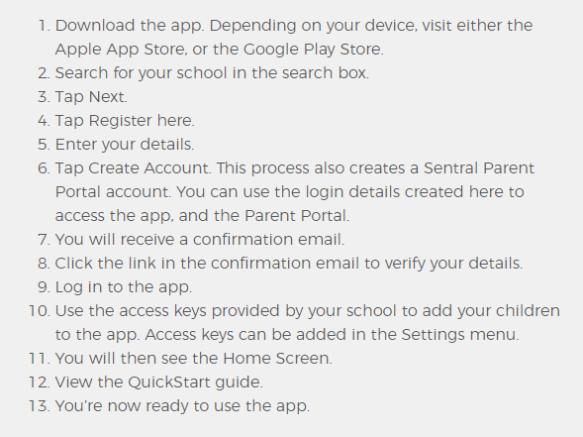

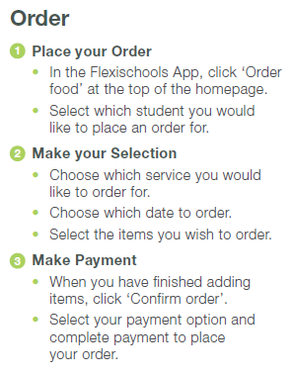**APPENDIX C: Accessing Flexischools**

