HUNTERS HILL PUBLIC SCHOOL

SCHOOL ATTENDANCE GUIDELINES

2022
Hunters Hill Public School Attendance Guidelines
Rationale
Regular attendance at school is essential to assist students to maximise their potential. Schools, in partnership with parents, are responsible for promoting the regular attendance of students. Encouraging regular school attendance is a core school responsibility.

DET Policy Statement / The Law
- Section 22 of the Education Act (1990) states that it is the duty of the parent of a child of compulsory school age to cause the child:

a) to be enrolled at, and to attend, a government school or a registered non-government school, or
b) be registered for home schooling with the Board of Studies and to receive instruction in accordance with the conditions to which the registration is subject.
- All students who are enrolled at school, regardless of their age, are expected to attend that school whenever instruction is provided.
- Section 24 of the Act requires principals to maintain an attendance register (roll) in a form approved by the Minister. Attendance registers must be made available for inspection during school hours by a Board inspector or by any authorised person.

Aims
- To promote regular student attendance and punctual arrival to school.
- To ensure accurate attendance registers are maintained.
- To act promptly in the follow up of absences.
- To refer individual cases to Home School Liaison Officer (HSLO) if necessary.
- To develop and monitor attendance improvement plans, if required, in consultation with parents /carers/student/ district HSLO.

Responsibilities

Parents/Guardians must ensure:
their children of compulsory school age are enrolled in a government or registered non-government school, or registered with the Board of Studies for Home Schooling.

- their children who are enrolled at school attend every day the school is open for instruction.

- they provide an explanation for absences to the school within 7 days from the first day of any period of absence through means such as a telephone call, written note, email, or Skoolbag/Sentral. The 7 day timeframe for explaining absences is a requirement of the Education Act (1990).

- they work in partnership with the school to plan and implement strategies to support regular attendance at school. This includes communicating with the school if they are aware of issues impacting on their child’s attendance or engagement with school.

Class Teachers must:
- provide a caring teaching and learning environment which fosters students’ sense of wellbeing and belonging to the school community.

- promote regular attendance at school through teaching and learning activities that acknowledge the learning and support needs of students.

- maintain accurate records of student attendance.

- mark class roll accurately at the beginning of class time. (Please refer to Roll Marking Procedures in Appendix A and Attendance Register Codes in Appendix B).

- ensure students who are late to school or have a partial absence are signed in/out by their parents at the school office.

- after 2 days unexplained absence, phone home, record explanation (Appendix C: Note 3 Verbal Advice of Absence) and amend roll as appropriate. Repeat this process every two days.

- after 4 days if no satisfactory response, refer to your Assistant Principal to follow up.

- after 6 days unexplained absence, report to Assistant Principal/LST representative

- in the case of a student returning to school after an absence, advise the school office of any absence that remains unexplained after six (6) days for forwarding of Note 4 Explanation of Absence not Received (Appendix C) to parents.

- Monitor and report to Assistant Principal/LST representative ongoing periodical absences that may be less than two days and explained eg repeatedly being absent for a day or two each week/fortnight.

Assistant Principals must:
- set attendance and roll procedures as a regular item for team meetings.

- ensure new staff members are inducted in school attendance and roll marking procedures.

- request and conduct official meetings with parents/guardians of students whose attendance is of concern.
- refer problem cases to Principal if no attendance/punctuality improvements as a result of interventions.

Principal/ Deputy Principal must:
- ensure departmental, as well as school policies and procedures related to attendance are being followed by all staff.

- coordinate and supervise regular roll checks and LAMP monitoring to ensure early identification of students at risk of developing poor school attendance.

- ensure all records including details of transfers and exemptions are accessible to the Director Public Schools NSW, attendance officers and other personnel nominated by the Secretary Department of Education or Audit Directorate.

- promote open communication on issues affecting student attendance, including the availability of interpreters and translated materials relating to school attendance.

- plan and implement effective strategies to contact parents where there is a pattern of attendance concerns.

- send letter to parents expressing seriousness of attendance and warning of referral to HSLO.

- refer cases to HSLO if no attendance improvement.

- liaise regularly with HSLO in regards to referred cases.

- help develop, implement and evaluate individual attendance improvements plans with HSLO, AP, Class teacher, student and parents.

- collate and analyse whole school attendance data. Share with staff and send relevant data to district/regional centres when required.

- complete required forms for students requesting exemption from school. Send forms to School Education Director, if required.

Justified Reasons for Student Absences

Absences for reasons such as some of the following may be justified:
- Unavoidable medical or dental appointments (encourage appointments outside of school hours or close to home time)
- Religious holiday
- Urgent family situation (e.g. funeral)
- Sick or infectious disease

Children are not absent if they are:
- Representing the school at approved activities
- Attending alternative programs/schools
- Attending Stewart House
- Temporarily enrolled at another school

Their non-attendance at the school site should be marked as appropriate to the reason as per the attendance register codes (Appendix B).

Unjustified Reasons for Student Absences

Full day or partial absences for reasons such as, but not limited to, the following are not justified:

- Shopping
- Sleeping in
- Working around the house
- Mind siblings/other children/older relatives
- Minor family events such as birthdays
- Haircuts
- Weather conditions: rainy/windy/hot
- Frequent car problems
- Frequent late train/bus
- Airport/visitors from overseas
- Other member of family is sick
- Hospital visits to relatives/friends
- Head lice

APPENDIX A: ROLL MARKING PROCEDURES

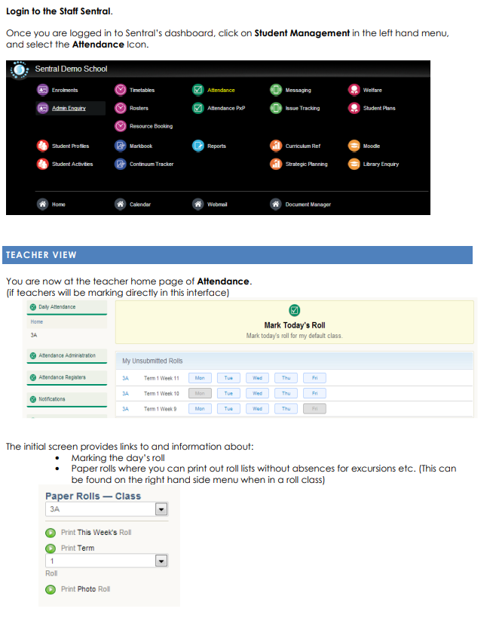

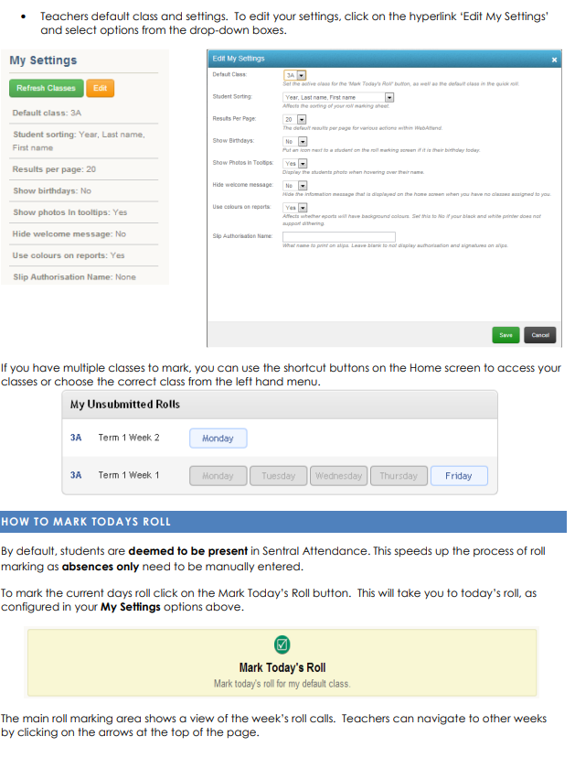

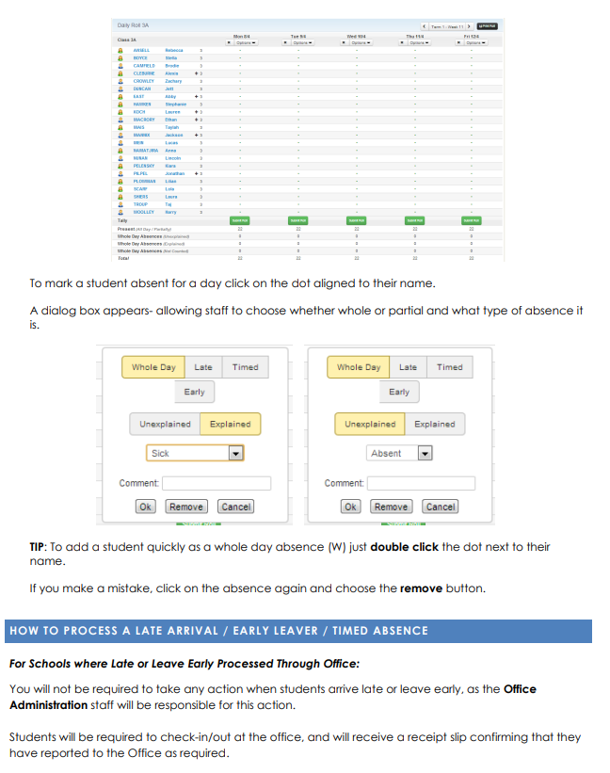

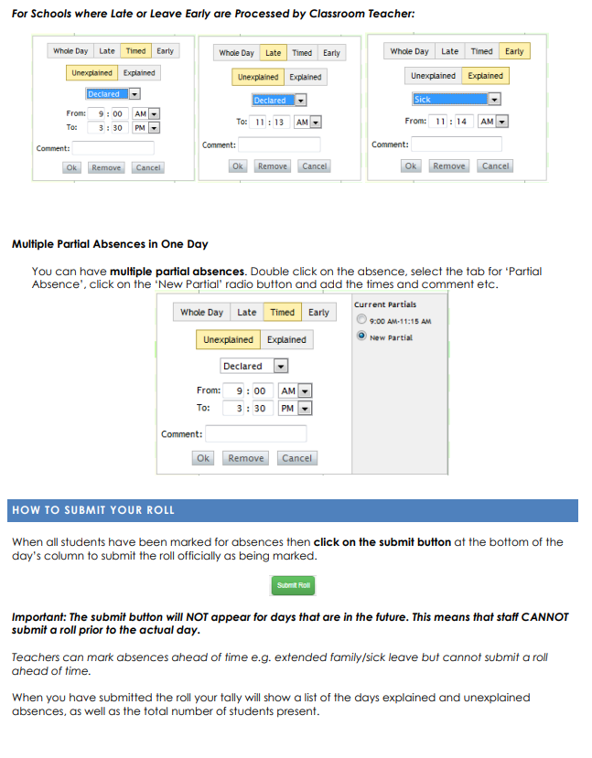

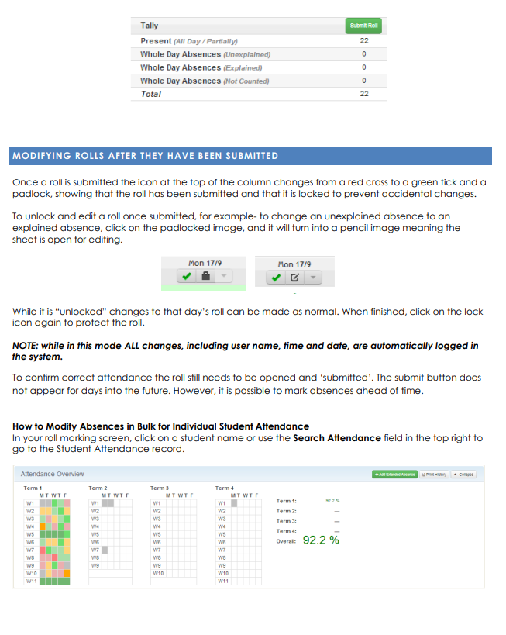

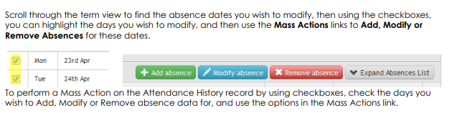
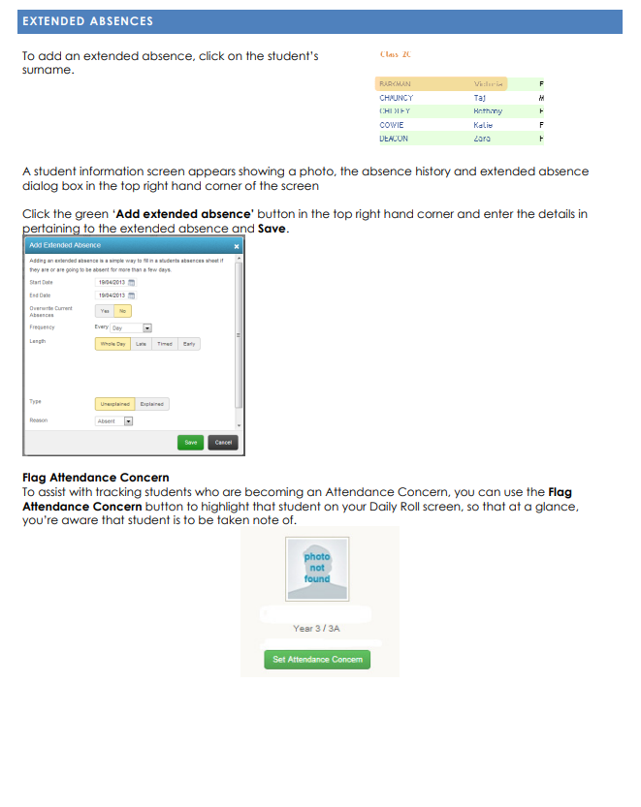
APPENDIX B: ATTENDANCE REGISTER CODES
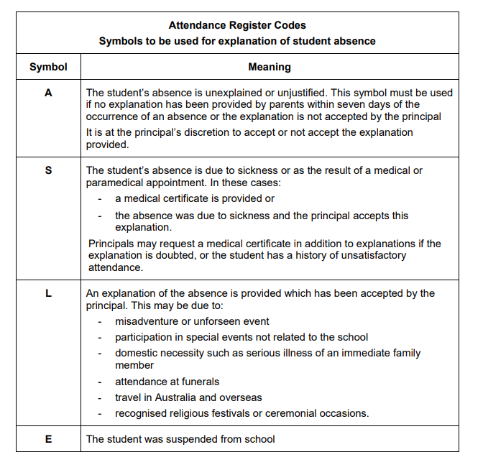

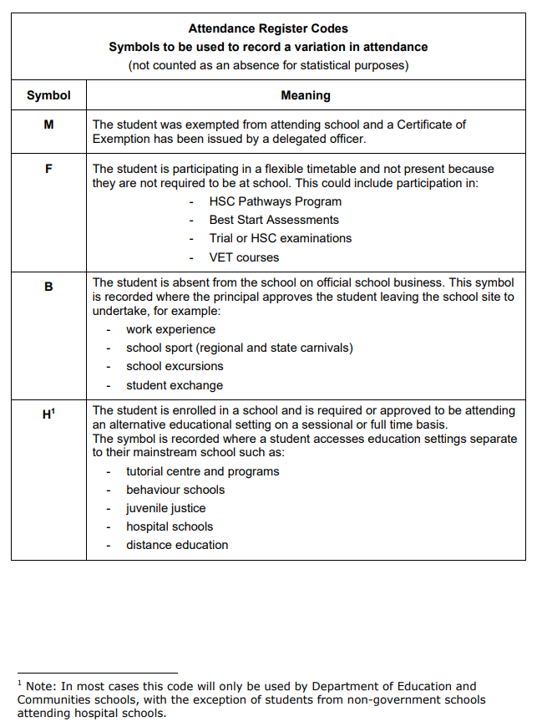
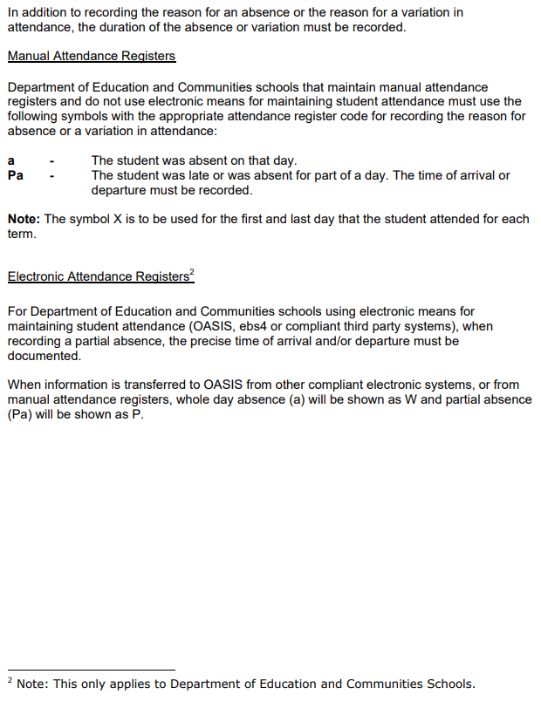
APPENDIX C: ABSENTEE NOTES
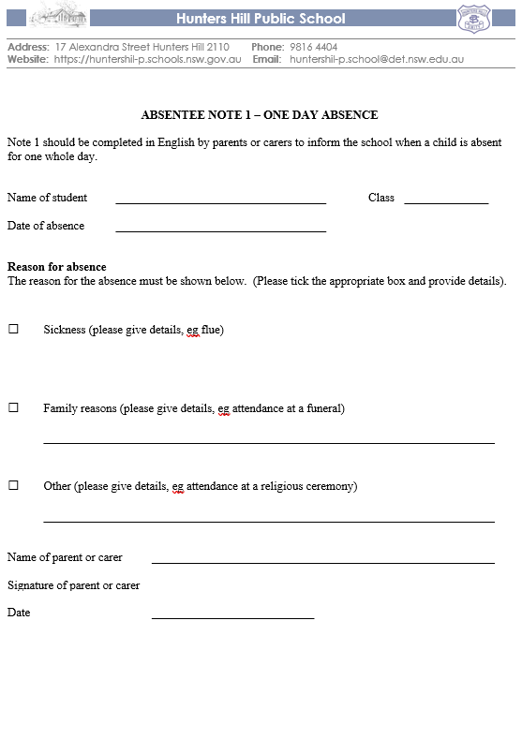

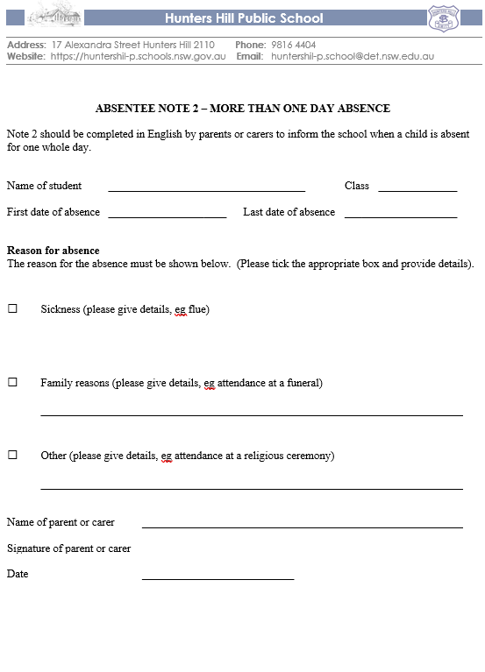

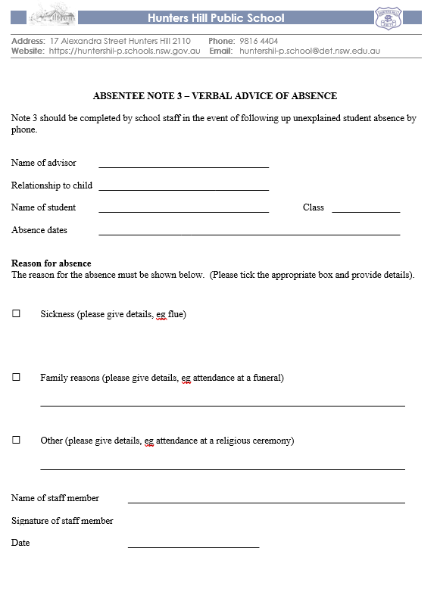

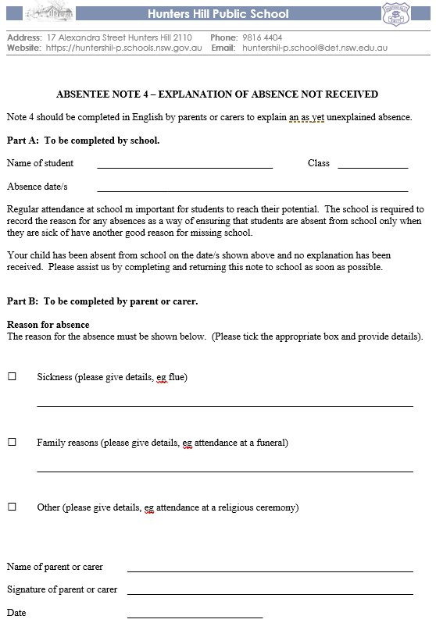
APPENDIX D: PARENT INFORMATION

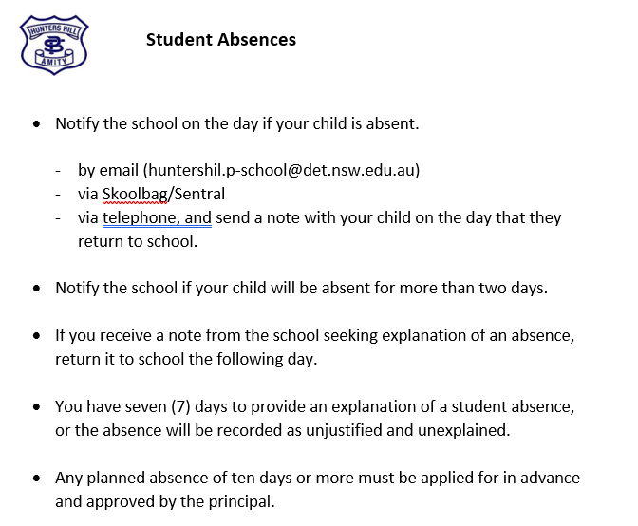

APPENDIX E: HOME SCHOOL LIAISON DOCUMENTS
